A Project Report on

**The Techno-Commercial Analysis of TATA Nexon EV**

By

**Harshit Varshney**

**Zakir Hussain College of Engineering and Technology**

**AMU**

Engineering Intern

Vardhan Consulting Engineers

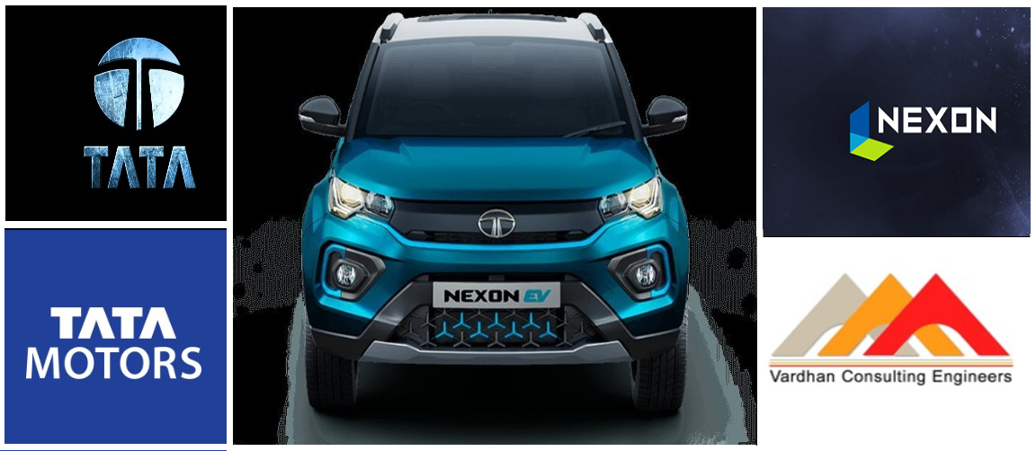

**ACKNOWLEDGEMENTS**

I would like to communicate my most profound appreciation to every one of the individuals who furnished me with the probability to finish this task report. A special gratitude I provide for my task Mentor, Mr Ashish S Kumar, CEO of The Vardhan Consulting Engineers whose commitment to invigorating ideas and support, assisted me with planning my task particularly writing this report.

A special thanks go to the teachers of the ZHCET, AMU who assisted me with recognizing the issue proclamation and recommended the genuine solutions of Electric vehicles. In the current universe of rivalry, there is a race of presence wherein those are having the will to approach to succeed. A task resembles an extension among hypothetical and functional working. With this readiness, I joined this specific venture. Additionally, I might want to uncover the HR Manager Neha Kumari Ma'am who offered me this awesome temporary position chance at Vardhan Consulting Engineers, Bangkok, Thailand.

Yours Faithfully,

**Harshit Varshney**

**EXECUTIVE SUMMARY**

The project is a Techno-Commercial analysis of the Tata Nexon EV which is an electric vehicle and runs on batteries. Uncovered in the year 2019. The Tata Nexon EV is Tata Motors second creation

electric vehicle and depends on the current Tata Nexon. In this report, I have examined techno-commercial highlights of Tata Nexon EV, what it means for our general public and how it tends to be advantageous. Strategy for examination incorporates pattern, vertical and even correlations, diagrams. It has a single electric motor driving the front wheels 95 kW and 245 Nm—enough to take the 4.3-meter-long hybrid from 0–60 kph in 4.6 seconds. The battery size is 30.2kWh. Tata Nexon EV's high energy thickness Lithium-battery pack is viable with CCS 2 quick charging standard and supports home and office accusing of any 15A attachment point.

M/s Vardhan Consulting Engineers "VCE" is an administration counselling firm, which gives consultancy to energy and framework engineers to raise obligation and value for their activities

as far as undertaking finance (non-response obligation) and private value. For doing this the techno-commercial analysis and specialists at VCE set up an insightful report of the ventures and perform the analysis and sort out the significance and necessities of EVs.

As an Engineering Intern at VCE, I was given the chance to deal with a case and help VCE in setting up a task report on techno-commercial analysis of Tata Nexon EV.

**CONTENTS**

**ACKNOWLEDGEMENTS** 2

**EXECUTIVE SUMMARY** 3

**CONTENTS** 4

**LIST OF FIGURES** 6

**LIST OF TABLES** 7

**1.** **INTRODUCTION** 8

1.1 Project Background 8

1.2 TATA Motors 9

**2.** **TATA NEXON EV** 10

2.1 TECHNICAL SPECIFICATIONS: 12

2.1.1 Performance and Drive 12

2.1.2 Battery and Charging 12

2.1.3 Energy Consumption 14

2.2 SAFETY STANDARDS 14

2.2.1 Dual Airbags 15

2.2.2 ABS with EBD & Corner Stability Control 15

2.2.3 Reinforced Body Structure 16

2.2.4 Liquid Cooled Battery Pack Rated IP67 16

2.2.5 ISOFIX Anchorage 17

2.3 WEIGHT AND DIMENSIONS 17

2.4 CHARGING INFRASTRUCTURE 18

2.4.1 Home and Destination Charging (0 to 100%) 18

2.4.2 Fast Charging (10 to 80%) 18

**3. EV COMPARISON** 20

3.1 PRICE: 20

3.2 DIMENSIONS: 20

3.3 SPECIFICATIONS: 21

3.4 THE RIDE STUFF: 22

**4. CONCLUSION** 23

**5. REFERENCES** 24

**LIST OF FIGURES**

Figure 1. Front View of Tata Nexon EV .................................................................. 10

Figure 2. Side View of TATA Nexon EV ................................................................ 11

Figure 3. Top View of Tata Nexon EV ..................................................................... 11

Figure 4. Charging .................................................................................................... 13

Figure 5. Interior View of Tata Nexon EV ............................................................... 14

Figure 6. ABS with EBD & Corner Stability Control .............................................. 15

Figure 7. Reinforced Body Structure ........................................................................ 15

Figure 8. Dual Airbags …………….......................................................................... 16

Figure 9. Liquid Cooled Battery Pack Rated IP67 .................................................... 16

Figure 10. ISOFIX Anchorage .................................................................................. 17

Figure 11. Smart Connect ......................................................................................... 18

Figure 12. Best Features ............................................................................................ 19

Figure 13. TATA Nexon EV vs MG ZS EV vs Hyundai Kona EV ......................... 20

**LIST OF TABLES**

Table 1. Sales Number over the years (in Rs. Cr) ...................................................... 9

Table 2. Performance ................................................................................................ 12

Table 3. Charging time for different Scenarios ........................................................ 13

Table 4. EVDB Real Range ...................................................................................... 14

Table 5. Safety Standards ......................................................................................... 14

Table 6. Weight and Dimensions .............................................................................. 17

Table 7. Other Features ............................................................................................. 19

Table 8. Price Comparison ........................................................................................ 20

Table 9. Dimension Comparison .............................................................................. 21

Table 10. Specification Comparison ........................................................................ 21

1. **INTRODUCTION**
   1. **Report Background**

Street EVs incorporates a huge scope of vehicles from electric bikes, three-wheelers (carts), vehicles and electric transports. Additionally, plug-in electric vehicles can be arranged into two types: battery electric vehicles (BEVs), and plug-in hybrid electric vehicles (PHEVs). BEVs have an electric motor instead of combustion engine and use power from the grid stored in batteries. Plug-in hybrid electric vehicles (PHEV) use batteries to control an electric engine what's more, fluid fuel like gas or diesel to control an inner combustion engine or another propulsion source.

EVs can go past the previously mentioned innovation-based grouping and can be arranged dependent on their properties like I) charging time, ii) driving range and iii) the most extreme burden it can convey. Of these attributes, the two most important characteristics of an electric vehicle of concern to the consumer are :-

1. Driving range.

2. Charging time of batteries and charging time depends on the input power characteristics, battery type, and battery capacity.

The central and state governments have dispatched plans and incentives to advance electric mobility in the country and a few guidelines and norms are likewise set up. While the country stands to profit generally by changing its vehicle from IC motors to electric engine controlled, there are difficulties like absence of charging foundation, high starting expense, and absence of power created from environmentally friendly power. All things considered, internet business organizations, vehicle producers, application-based transportation network organizations, and versatility arrangement suppliers have entered the area and are gradually developing electric vehicle limit and perceivability.

The National Electric Mobility Mission Plan 2020 was dispatched by the Government of India in 2020 to further develop public fuel security through the advancement of crossover and electric vehicles.

In India power is predominantly delivered by consuming coal, which creates an extraordinary number of greenhouse emissions. With the presentation of EVs and charging foundation, the power request will go up a ton and the general purpose of acquainting EVs with decrease GHG outflows would be insufficient if this power was created by consuming coal.

Additionally, India's Distribution organizations hold obligations and can't do the trick the energy prerequisite of the entire nation sufficiently. If EVs somehow happened to enter this condition, the abrupt expansion in power necessity would put an additional heap on these organizations. In addition, there are a great deal of variables that would go into choosing the estimating of the power just as the request on the lattice.

* 1. **TATA Motors**

TATA Motors Limited, officially Tata Engineering and Locomotive Company (TELCO), is an Indian worldwide car producing organization settle red in Mumbai, Maharashtra, India. It is a piece of Tata Group, an Indian combination. Its items incorporate traveller vehicles, trucks, vans, mentors, transports, sports vehicles, development hardware, and military vehicles.

TATA Motors has automobile assembling and gathering plants in Jamshedpur, Pantnagar, Lucknow, Sansand, Dharwad, and Pune in India, just as in Argentina, South Africa, Great Britain, and Thailand. It has innovative work habitats in Pune, Jamshedpur, Lucknow, and Dharwad, India and South Korea, Great Britain, and Spain. TATA Motors principal auxiliaries bought the English premium vehicle creator Jaguar, Land Rover, and the South Korean business vehicle maker Tata Daewoo.

**Table 1. Sales Number over the Years (in Rs. Cr)**

|  |  |  |  |
| --- | --- | --- | --- |
| **Calendar Year** | **Net Sales/Income from operations** | **Other Operating Income** | **Total Income from Operations** |
| **2011** | 47,807.42 | 233.04 | 48,040.46 |
| **2012** | 54,005.40 | 301.16 | 54,306.56 |
| **2013** | 44,373.04 | 392.68 | 44,795.72 |
| **2014** | 33,906.97 | 381.14 | 34,288.11 |
| **2015** | 35,890.50 | 404.24 | 36,294.74 |
| **2016** | 42,845.47 | - | 42,845.47 |
| **2017** | 44,831.41 | - | 44,363.60 |
| **2018** | 68,764.88 | - | 58,831.41 |
| **2019** | 43,485.76 | 437.88 | 69,202.76 |
| **2020** | 43,485.76 | 442.41 | 43,928.17 |
| **2021** | 46,559.39 | 472.08 | 47,031.47 |

1. **TATA NEXON EV**

The Tata Nexon EV is India's Premium Electric Car. A step in a similar way, Tata Nexon EV, the worldwide EV is intended for the rare sorts of people who might want every one of the advantages of a zero-tailpipe emanation vehicle yet in style. The Tata Nexon EV doesn't think twice about feeling, has a fantastic form quality, would excite you with its presentation and IP67 confirmed battery and motor.

Tata Nexon EV was revealed in India on December 19, 2019. Goodbye Nexon EV is the second electric vehicle after Tata Tigor EV. The Nexon EV will be a welcome expansion to the country's EV portfolio that as of now incorporates some impressive players like Hyundai Kona and MG ZS EV.

It has a single electric motor driving the front wheels 95 kW and 245Nm is sufficient to take the 4.3-meter-long hybrid from 0–60 kph in 4.6 seconds. Battery size is 30.2kWh. Tata Nexon EV's high energy thickness Lithium-Ion battery pack is viable with CSS 2 quick charging standard and supports home and office accusing of any 15A attachment point. Likewise, the battery as well as the motor, will both be offered with a warranty of eight years/1.6 lakh km.

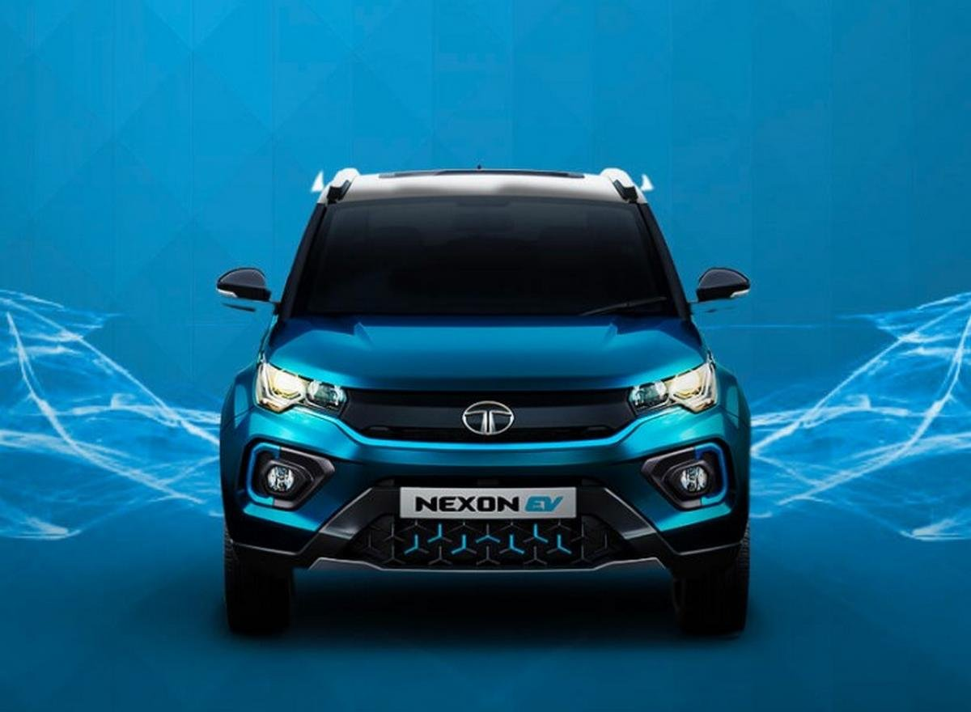**Figure 1. Front View of Tata Nexon EV**

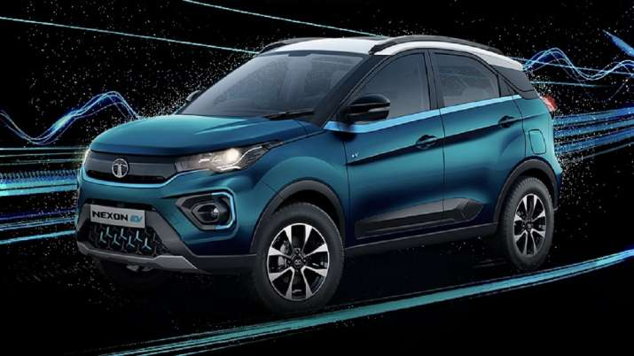**Figure 2. Side View of Tata Nexon EV**

**Figure 3. Top View of Tata Nexon EV**



* 1. **TECHNICAL SPECIFICATIONS:**
     1. **Performance and Drive:**

**“What it’s like to drive and how quiet it is”**

One of the most vulnerable space of the petroleum controlled Nexon is its lazy performance, and this electric variant is a whole lot speedier. The authority 0-60kmph sprint takes a very good 4.6sec, and you never feel like you need any more zip, even on quicker A-roads. In the one region that Tata has dominated, even contrasted and most significant EV players: the anticipated reaction of the Tata Nexon EV's brake pedal. You can undoubtedly judge how much strain to apply on the off chance that you need to back off easily, while the regenerative slowing mechanisms in numerous other electric vehicles unleash devastation with that consistency, making you either press the pedal excessively hard or not hard enough. Shouldn't something be said about its charging time? The Nexon EV can take up to 30.2kW from a public CCS point, giving a 0-80% top-up in around an hour.

**Table 2. Performance**

|  |  |
| --- | --- |
| **Parameters** | **Values** |
| **Acceleration 0 - 100 km/h** | 9.9 sec |
| **Top Speed** | 120 km/h |
| **Electric Range** | 312 km |
| **Total Power** | 127 bhp |
| **Total Torque** | 245 Nm |
| **Drive** | Front |

* + 1. **Battery and Charging:**

The table beneath shows the assessed time to charge your Tata Nexon EV from empty to full. For fast charging, we show an opportunity to charge from 0% - 80%, as charging tends to moderate external this reach to ensure the battery.

The electric Car offers an asserted scope of 321km on a full charge. It will be appraised at 30.2kWh, Nexon EV will do as such by utilizing cells that can hold more charge within them. A greater battery pack would preferably imply that charging times will likewise increment. The current 30.2kWh battery pack requires under an hour to charge from 0 to 80 percent. The Nexon EV can be completely energized in 8.5 hours and on the off chance that you need to utilize the emergency portable charger provided with the vehicle, it will require as long as 19 hours utilizing a 15A attachment.

**Table 3. Charging time for different**

|  |  |  |  |
| --- | --- | --- | --- |
| **Charging method** | **Typically found at Charging time\*** | | **Range/hour\*\*** |
|  | **Empty to full** | |  |
|  | **0% to 80%** | |  |
| **30.2kW** | CSS 2 (fast charging) | 60 min | 86 m/30 min |
|  | **10% to 90%** | |  |
| **30.2kW** | Home (15 AMP Plug) | 8.5 hr | 510 min |

**Figure 4. Charging**

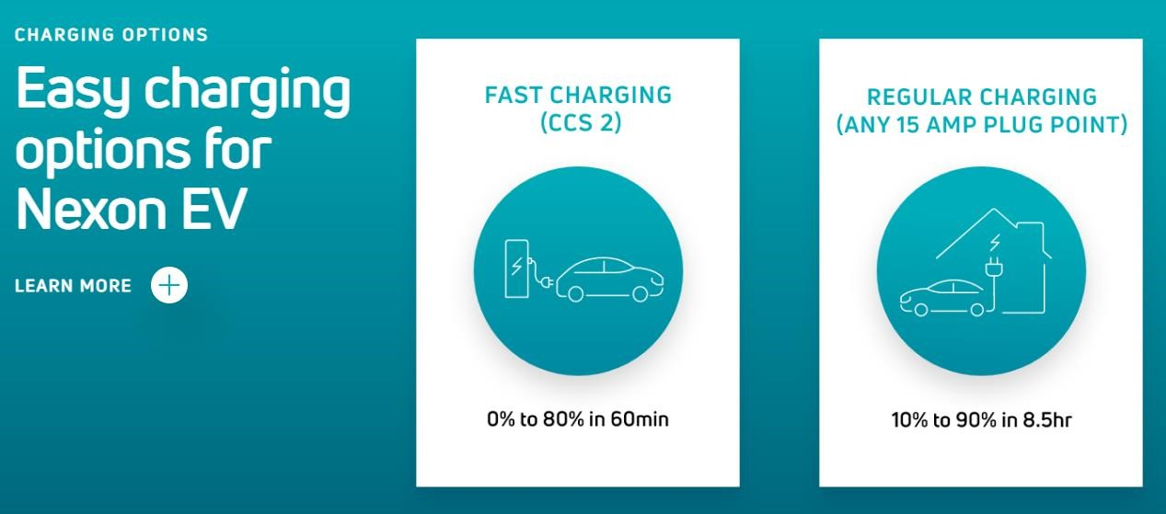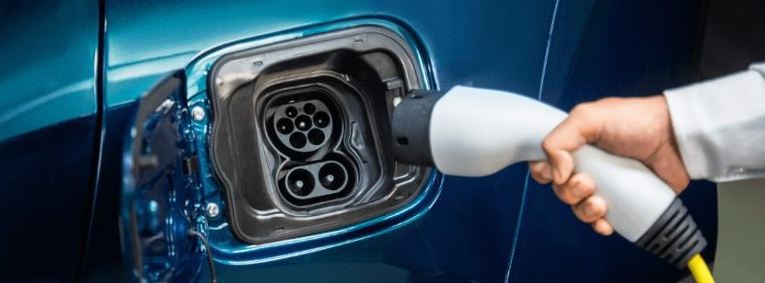

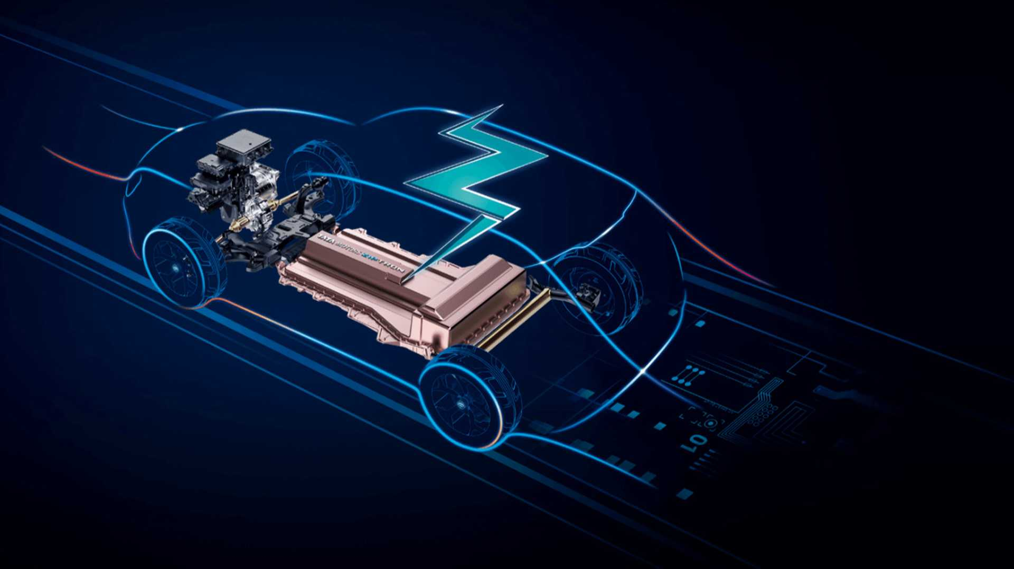**Figure 5. Interior View of Tata Nexon EV**

* + 1. **Energy Consumption:**

EV Database Real Range

**Table 4. EVDB Real Range**

|  |  |
| --- | --- |
| **Parameter** | **Values** |
| **Range** | 212 km |
| **Vehicle Consumption** | 193 Wh/km |
| **CO2 Emissions** | 0 g/km |
| **Vehicle Fuel Equivalent** | 2.2 l/100km |

* 1. **SAFETY STANDARDS:**

**Table 5. Safety Standards**

|  |  |
| --- | --- |
| Safety Rating |  |
| **Adult Occupant** | 90% |
| **Child Occupant** | 85% |
| **Rating Year** | 2020 |
| **Vulnerable Road Users** | 64% |
| **Safety Assist** | 70% |

* + 1. **ABS with EBD and Corner Stability Control**

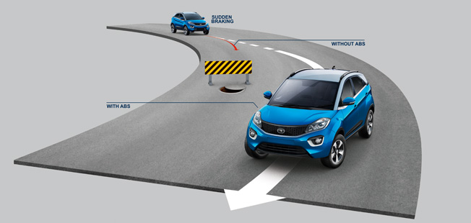**Figure 6. ABS with EBD & Corner Stability Control**

Equipped with the most recent 9.3 age Anti-lock Braking System, Electronic Brake Distribution System, and Cornering Stability Control, the Tata Nexon EV checks all the cases with regards to keeping you in control.

* + 1. **Reinforced Body Structure**

**Figure 7. Reinforced Body Structure**

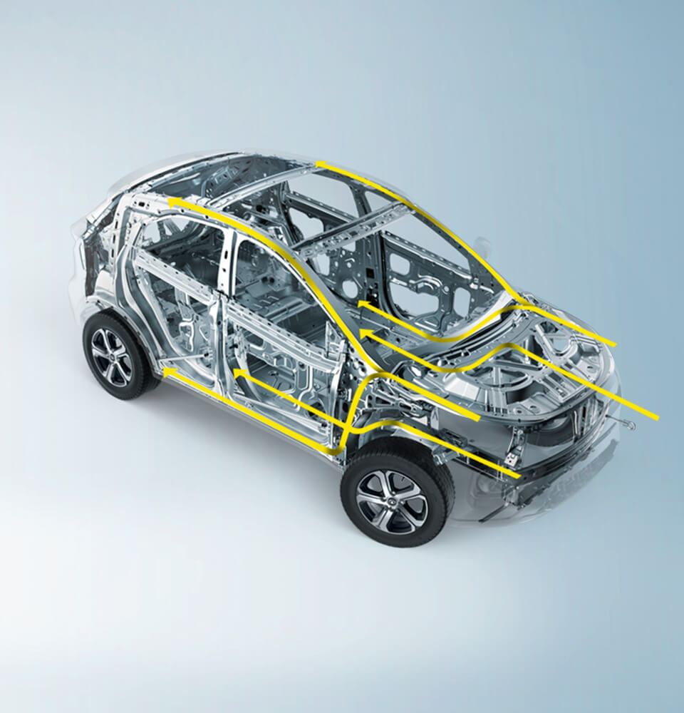

Nexon EV's rigid design of supported steel and energy-engrossing body structure goes along with the most recent full-front facing, side-impact, and offset sway crash guidelines.

* + 1. **Dual Airbags:**

**Figure 8. Dual Airbags**

With an expectation to build customer safety, the Tata Nexon EV depends on its Dual Airbags to guarantee the security of both, the Driver and the Co-driver.

* + 1. **Liquid Cooled Battery Pack Rated IP67**

**Figure 9. Liquid Cooled Battery Pack Rated IP67**

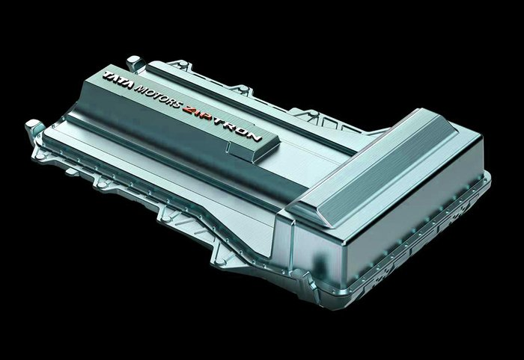

Nexon Electric has a 30.2 kWh battery pack, which gives 129hp power and 254 Nm of torque. The company has given Lithium-ion battery pack in it, which has been specially tested keeping in mind the Indian roads and environment.

* + 1. **ISOFIX Anchorage**

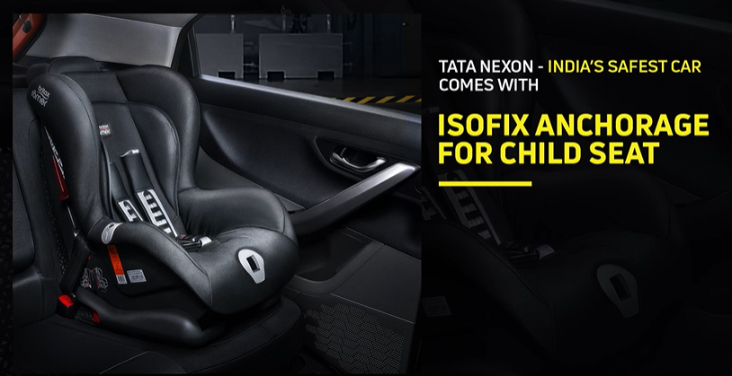**Figure 10. ISOFIX Anchorage**

Nexon EV is furnished with ISOFIX mooring for youngster seats to guarantee free from any dangerous drivers for your little ones.

* 1. **WEIGHT AND DIMENSIONS:**

**Table 6. Weight and Dimensions**

|  |  |
| --- | --- |
| **Parameter** | **Values** |
| **Length** | 3993 mm |
| **Width** | 1811 mm |
| **Height** | 1606 mm |
| **Wheelbase** | 2498 mm |
| **Kerb Weight** | 205mm |
| **Ground Clearence** | 1966 kg |

Tata Nexon EV measurements 3993 mm long, 1811 mm in width, and 1606 mm in height, with a wheelbase of 2498 mm, you can likewise check the Tata Nexon EV measurement changed over into CM (centimetre), Inches, and feet for all variations of the vehicle.

* 1. **CHARGING INFRASTRUCTURE:**
     1. **Fast Charging (10 to 80%)**

Fast charging empowers longer excursions by adding however much reach as could be expected in the briefest measure of time. The charging force will diminish essentially after 80% condition of charge has been reached. An ordinary fast charge hence once in a while exceeds 80% SOC. The fast charge pace of an EV relies upon the charger utilized and the greatest charging power the EV can deal with.

• Max. Power: maximum power provided by charge point.

• Avg. Power: average power provided by charge point over a session from 10% to 80% • Time: time needed to charge from 10% to 80%.

• Rate: average charging speed over a session from 10% to 80%

* + 1. **Home and Destination Charging**

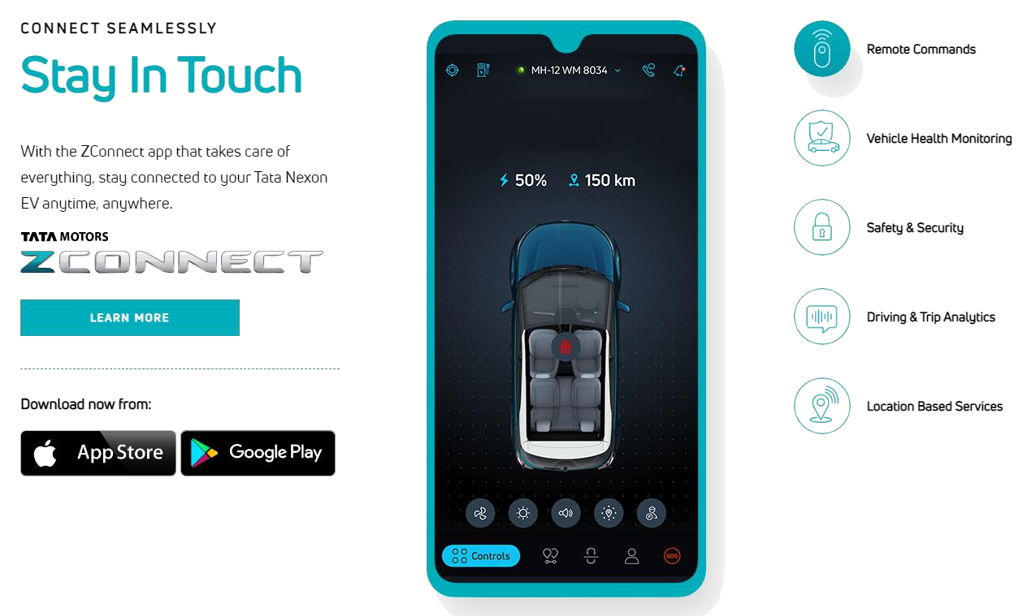**Figure 11. Smart Connect**

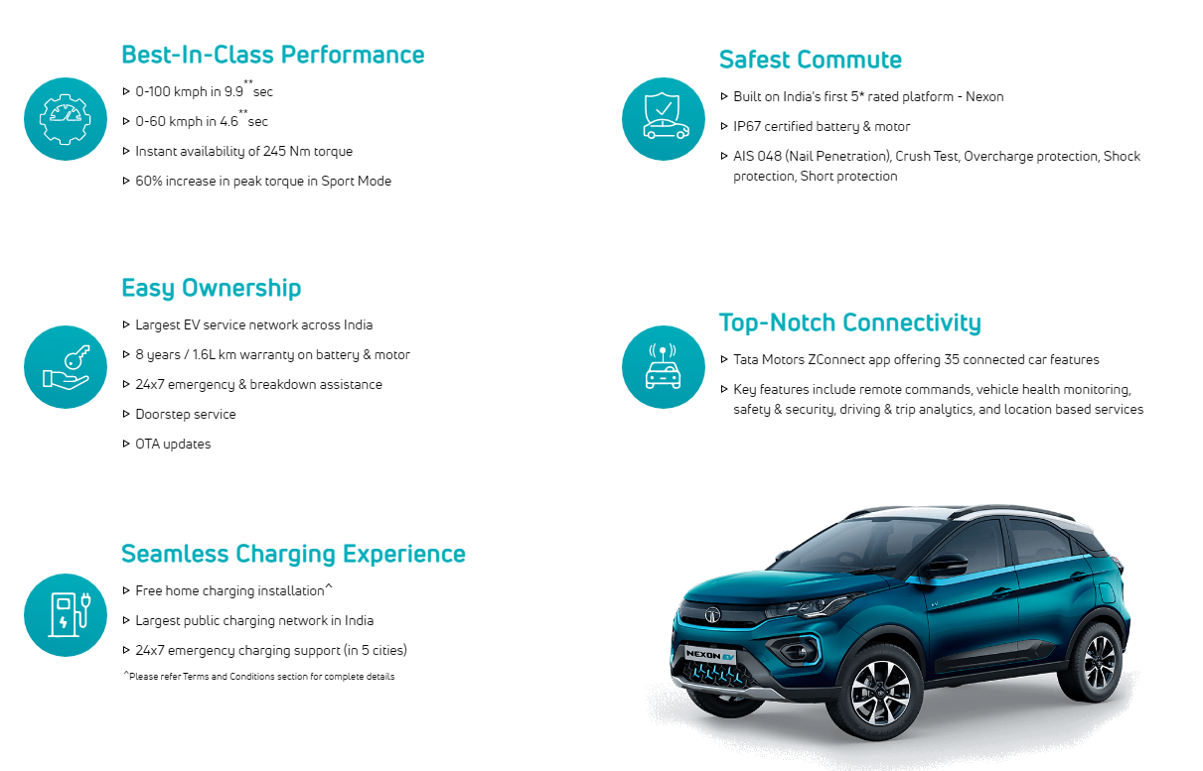**Figure 12. Best Features**

**Table 7. Other Features**

|  |  |
| --- | --- |
| **Parameters** | **Values** |
| **Cargo Volume** | 350 L |
| **Drive modes** | Multi-Drive Modes (Drive & Sports) |
| **Thermal management system** | Liquid Cooled |
| **Gradeability (%)** | 34% |
| **Roof Load** | 75 kg |
| **Max. Payload** | 410 kg |
| **Seats** | 5 people |
| **Iso-fix** | Yes, 2 seats |
| **Turning Circle** | 5.1 m |
| **Car Body** | SUV |
| **Energy efficiency (Wh/km)** | 100* |
| **Roof Rails** | Yes |

1. **EV COMPARISON**

Here we are comparing TATA Nexon EV and diverse electric vehicles accessible in the Indian market like MG ZS EV and Hyundai Kona EV.

**\*\* TATA Nexon EV vs MG ZS EV vs Hyundai Kona EV \*\***

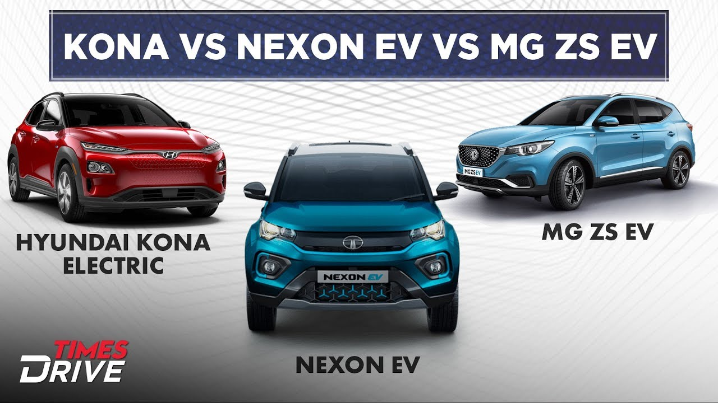**Figure 13. TATA Nexon EV vs MG ZS EV vs Hyundai Kona EV**

* 1. **PRICE:**

Tata Nexon EV is required to be estimated between Rs 15-17 lakh, while the MG ZS EV would come as more premium with a tag price around Rs 25 lakh. Hyundai sells the Kona EV at Rs 23.71 lakh.

**Table 8. Price Comparison**

|  |  |  |
| --- | --- | --- |
| **Tata Nexon EV** | **MG ZS EV** | **Hyundai Kona EV** |
| **Rs 15 - 17 lakh (estimated)** | **Rs 25 lakh (estimated)** | **Rs 23.71 - 23.90 lakh** |

* 1. **DIMENSIONS:**

Based on the Nexon facelift, the Tata electric SUV measures, 3,994 mm in length, 1,811 mm in width and 1,607 mm in height. It has a wheelbase of 2,498 mm and a ground clearance of 205 mm.

**Table 9. Dimension Comparison**

|  |  |  |  |
| --- | --- | --- | --- |
| Parameters | **Tata Nexon EV** | **MG ZS EV** | **Hyundai Kona EV** |
| **Length** | 3,994 mm | 4,314 mm | 4,180 mm |
| **Width** | 1,811 mm | 1,809 mm | 1,800 mm |
| **Height** | 1,607 mm | 1,611 mm | 1,570 mm |
| **Wheelbase** | 2,498 mm | 2,585 mm | 2,600 mm |
| **Ground Clearance** | 205 mm | 161 mm | 158 mm |

MG ZS EV is based on the standard ZS SUV. It measures 4,314 mm in length, 1,809 mm in width, and 1,611 mm in height. Dimensionally, the Hyundai Kona EV measures 4,180 mm in length, 1,800 mm in width, 1,570 mm in height and it has a wheelbase of 2,600 mm.

* 1. **SPECIFICATIONS:**

**Table 10. Specification Comparison**

|  |  |  |  |
| --- | --- | --- | --- |
| **Parameters** | **Tata Nexon EV** | **MG ZS EV** | **Hyundai Kona EV** |
| **Battery** | 30.2 kWh | 44.5 kWh | 39.2 kWh |
| **Power** | 129 PS | 150 PS | 136 PS |
| **Torque** | 245 Nm | 350 Nm | 395 Nm |
| **Range** | 300 km | 340 km | 452 km |
| **Motor** | Permanent Magnet Synchronous | Permanent Magnet Synchronous | Permanent Magnet Synchronous |
| **PERFORMANCE** | Acceleration (from rest) | Acceleration (from rest | Acceleration (from rest |
| **20kph** | 1.51s | 1.18s | 1.21s |
| **40kph** | 2.87s | 2.39s | 2.44s |
| **60kph** | 4.36s | 3.79s | 4.00s |
| **80kph** | 6.47s | 5.82s | 6.16s |
| **100kph** | 9.30s | 8.53s | 9.09 |
| **120kph** | 16.12s | 12.38s | 12.92s |
| **Portable Charger** | 10 hr (3.3kW) | 20 hr | 19 hr (2.8kW) |
| **AC Wall Box** | - | 6-8 hr (7kW;0-80%) | 6.2hr;7.2kW;0-100% |
| **DC fast charger** | 1 hr (25kW) | 50 min (50kW) | 1 hr (50kW) |

TATA Nexon EV will be powered by a 129 PS of force and 245 Nm of force creating an electric motor joined with a 30.2 kWh lithium-ion battery. The SUV will accompany two driving modes, which are Drive and Sport. It will actually want to speed up to 100 kmph from stop position in 9.9 seconds, while the SUV will actually want to run 300 km on a single charge asserts the automaker.

The MG ZS EV, then again, draws power from an electric motor that produces 150 PS of force and 350 Nm of torque. The electric motor is clubbed with a 44.5 kWh battery pack. The SAIC-possessed automaker asserts this electric SUV will actually want to run 340 km on a single charge.

Hyundai Kona EV is powered by a Permanent Magnet Synchronous Motor (PMSM), which produces 136 PS of peak power and 395 Nm of torque yield. It gets a 39.2 kWh battery ready and the SUV offers 452 km of reach on a completely charged battery.

* 1. **THE RIDE STUFF**

Like the standard Tata Nexon, the Nexon EV scores well on ride and taking care of. It feels strong, adjusts the knocks best and the smooth directing is additionally ideal to utilize. The Nexon's moderately little size makes it the most straightforward to stop as well. You'll likewise like how unhesitatingly the Nexon EV shifts bearing. However, you should be estimated with your choke contributions out of corners, particularly in Sport mode. There's no ESC or traction control to get control over the force and hard speed increase will in general overpower the Nexon's front tires.

You'll hear a chirp from the Kona's tires occasionally, however, the gadgets rush to kick in to monitor things. The Kona feels the most powerful, if by some stroke of good luck just, and it has agreeable guiding as well. In any case, the Kona has the most outside sound and will in general feel burdensome over awful streets as well.

The MG ZS EV separates itself from the most hushed cabin. You hear insignificant outside sound and surprisingly the engine cry sounds the most far off. Once in a while, a thud from the MG's suspension will break the quiet inside. Ride solace is acceptable regardless of whether there is a fundamental solidness to the arrangement.

1. **CONCLUSION**

This project deals with the Techno-commercial analysis of Tata Nexon EV by Tata Motors, an extension of Tata Nexon (crossover). In the project report, I have analysed all the necessary specifications, requirements, comparisons pros, cons, etc.

Tata Motors India will start selling the electric SUV in five cities: Delhi-NCR, Hyderabad, Mumbai, Ahmedabad, and Bengaluru. The carmakers have clocked almost 3,000 pre-launch bookings of the SUV.

This report will help customers analyse and decide whether the car meets their needs or not or get into EVs and buy this car. It would be an amazing experience for the users who are trying EVs for the first time.

Inspired by various elements of the celestial bodies and Nature. Tata EV is all packed to fulfil your style quotient.

1. **REFERENCES**

* <https://en.wikipedia.org/wiki/Tata_Motor>
* <https://en.wikipedia.org/wiki/Nexon_EV_(crossover)>
* <https://timesofindia.indiatimes.com/business/india-business/mg-zs-ev-%20launched-starts-at-rs-20-88-%20lakh/articleshow/73545878.cms#:~:text=MG%20ZS%20EV%20review>
* <https://en.wikipedia.org/wiki/New_European_Driving_Cycle#:~:text=T%20he%20total%20test%20time%20amounts,standstill%20and%20combus%20tion%20engine%20off>.
* <https://niti.gov.in/writereaddata/files/document_publication/EV_report.pdf>
* <https://www.91wheels.com/cars/tata/nexon-ev/specifications?utm_source=google&utm_medium=cpc&utm_campaign=DSA%7CCar%7CTata%7CNexon%7CBMM&matchtype=b&device=c&campaignid=13602801326&loc_physical_ms=9040183&network=g&keyword=&placement=&loc_interest_ms=>
* <https://www.cardekho.com/tata/nexon-ev/price-in-new-delhi>
* <https://www.carwale.com/tata-cars/nexon-ev/price-in-delhi/#:~:text=Detailed%20breakup%20of%20price%20of,and%20Miscellaneous%20Charges%20%2D%20%E2%82%B9%206%2C950>
* <https://nexonev.tatamotors.com/features/>
* <https://www.autocarindia.com/car-news/heres-where-you-can-buy-the-nexon-ev-415763>
* <https://www.google.com/search?q=tata+nexon+images&rlz=1C1SQJL_enIN866IN866&oq=Tata+Nexon+Images&aqs=chrome.0.69i59j0l5j69i60l2.5920j0j7&sourceid=chrome&ie=UTF-8>
* <https://www.autocarindia.com/car-comparison-reviews/mg-zs-ev-vs-tata-nexon-ev-vs-hyundai-kona-electric-comparison-419879>
* <https://www.carwale.com/compare-cars/tata-nexon-ev-vs-mg-zs-ev/>